Day 4

30 November 2023

10:04

**Reports and dashboards**

16. Information Required by Higher Management (create reports accordingly): -

* + Create a Dashboard which would give quick view about **Customer** as per different sources.
  + Create a dashboard which would give quick view about restaurants ratings.

**Permission Set**

17. One user Mr. Sandy<<**Helpdesk user**>> having same profile needs edit access on **Customer** object

**Data Loader**

**18 . Perform all operations on Customer object: -**

* + Export
  + Export All
  + Insert
  + Update
  + Delete
  + Upsert

**Apex Batch & Schedulable:**

19. Create a mid-night daily job to delete all Rejected Reservation.

20. Create a min-night daily job which will reset the quantity of the Resource to original value.

Note: The Original value will depend on the Restaurant.

Diff btw   
1) =, ==, === in JS  
2) Subscribe Functionality in LWC, why function why not directly variable , is java script using pass by value or pass by reference

3) What is the purpose of defining Variable inside the method as well, if we already define above to the method in LWC

**Reports and dashboards**

16. Information Required by Higher Management (create reports accordingly): -

* + Create a Dashboard which would give quick view about **Customer** as per different sources.
  + Create a dashboard which would give quick view about restaurants ratings.

**Permission Set**

17. One user Mr. Sandy<<**Helpdesk user**>> having same profile needs edit access on **Customer** object

**Steps:  
We will take profile permissions for the customer object to the Helpdesk User profile**

**Use permission set to give permission to User Rajesh to the object customer**

**Done**

**Data Loader**

**18 . Perform all operations on Customer object: -**

1. Export
2. Export All
3. Insert
4. Update
5. Delete
6. Upsert  
     
     
   Insert

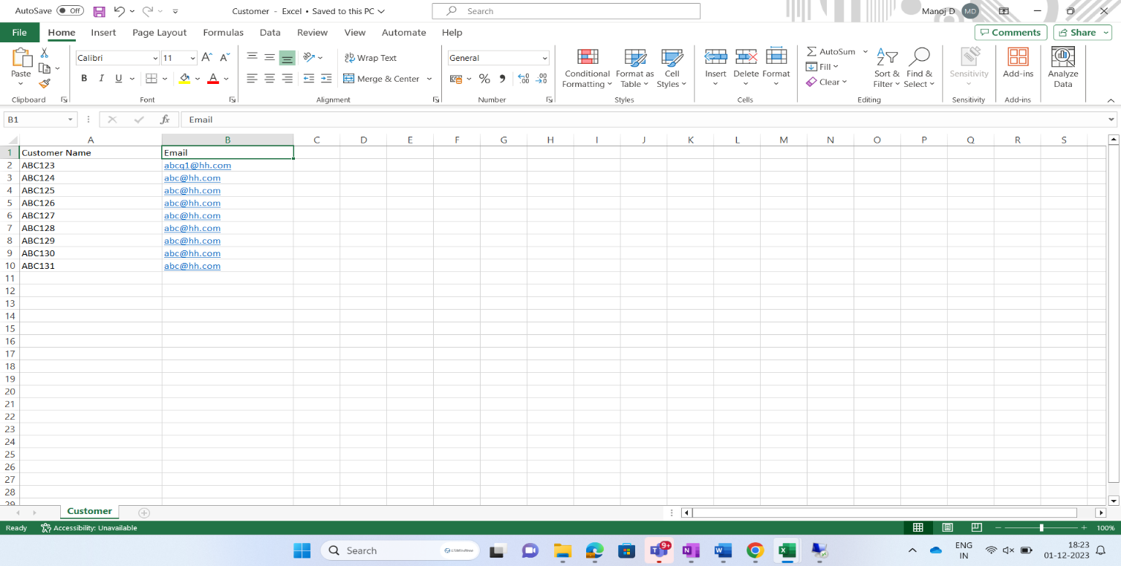

Upsert

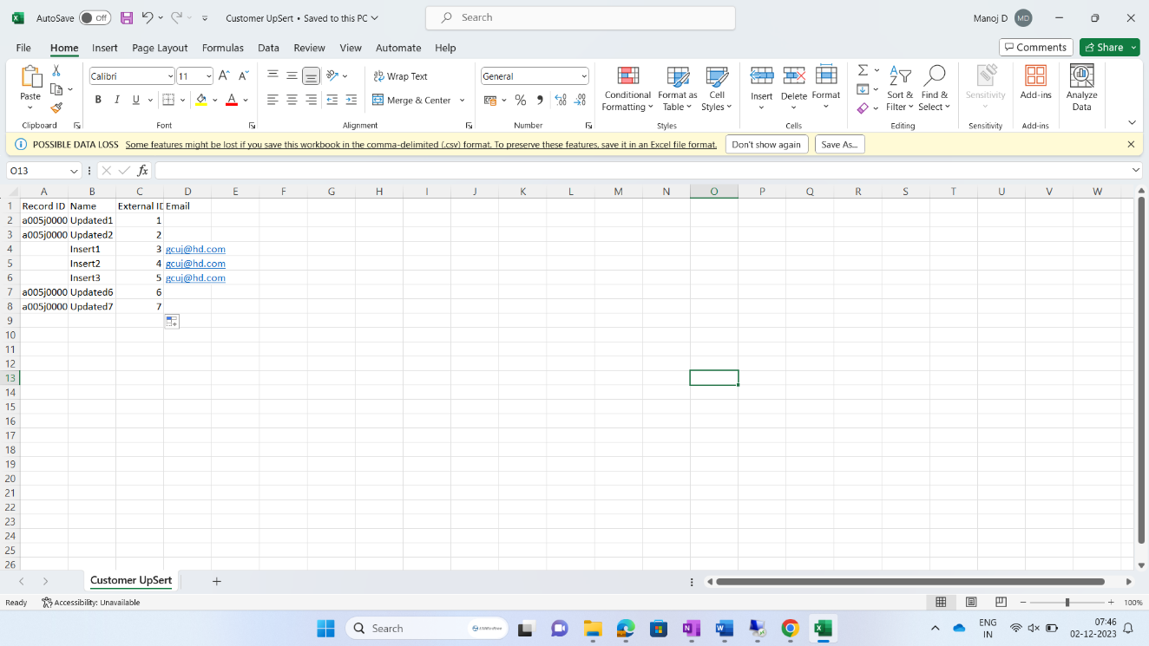

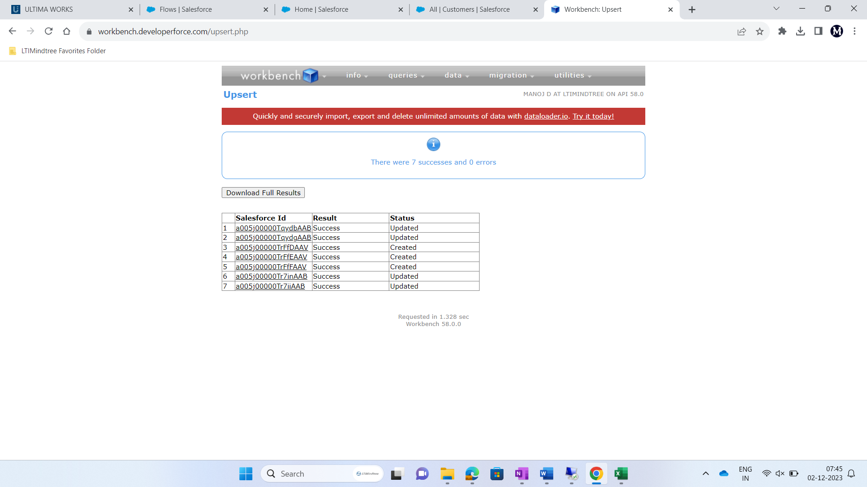

**Apex Batch & Schedulable:**

**19. Create a mid-night daily job to delete all Rejected Reservation.**

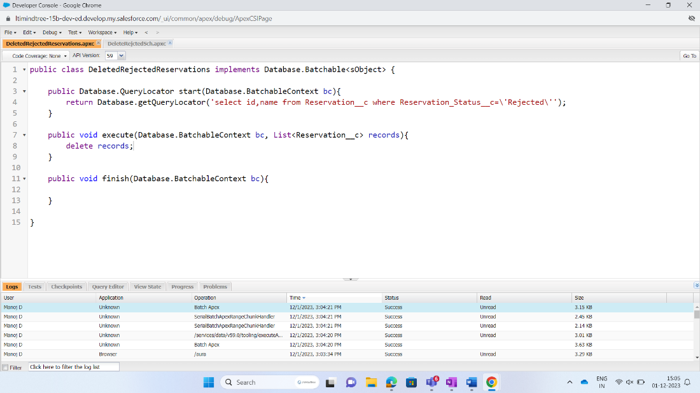

Create A schedule class and schedule it the **apex schedule**

**20. Create a min-night daily job which will reset the quantity of the Resource to original value.**

**Note: The Original value will depend on the Restaurant.**

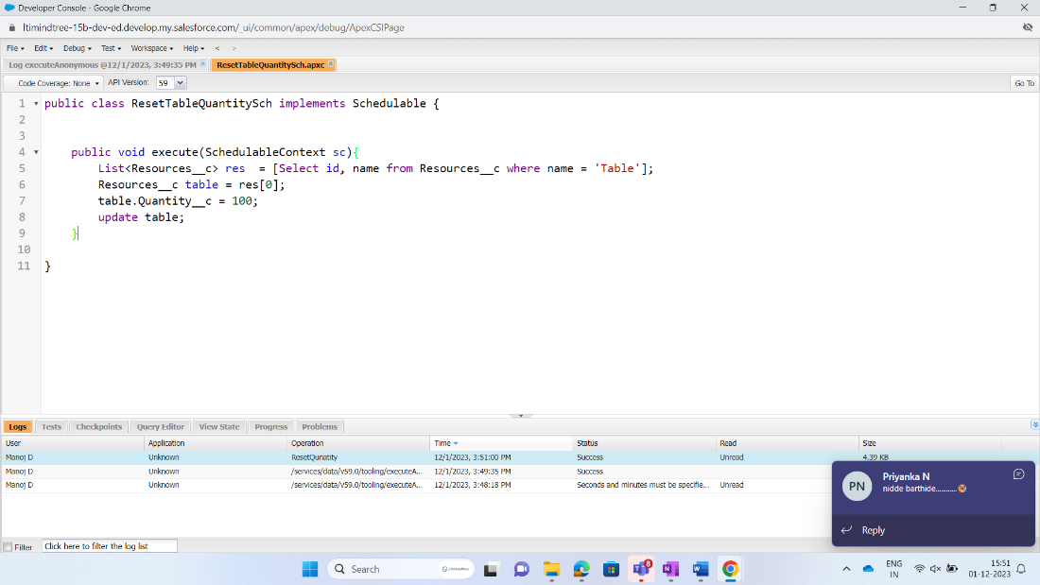

**Web Services**

21. Create a Webservices where you have to create a new record for **Customer** Object (**Customer**Id, **Customer**Name) from third party application using Workbench

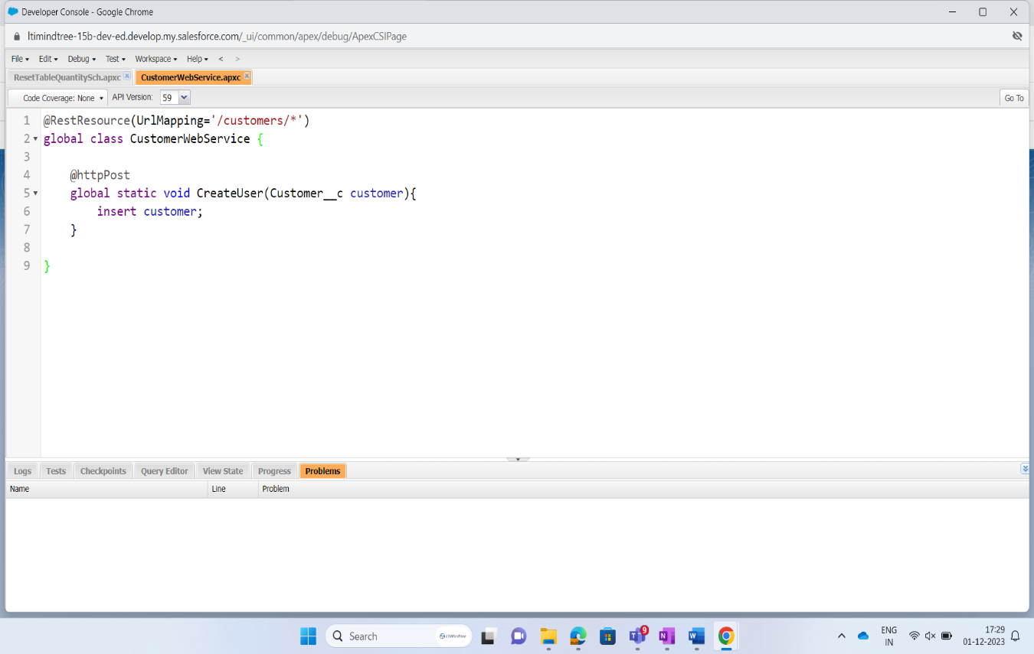

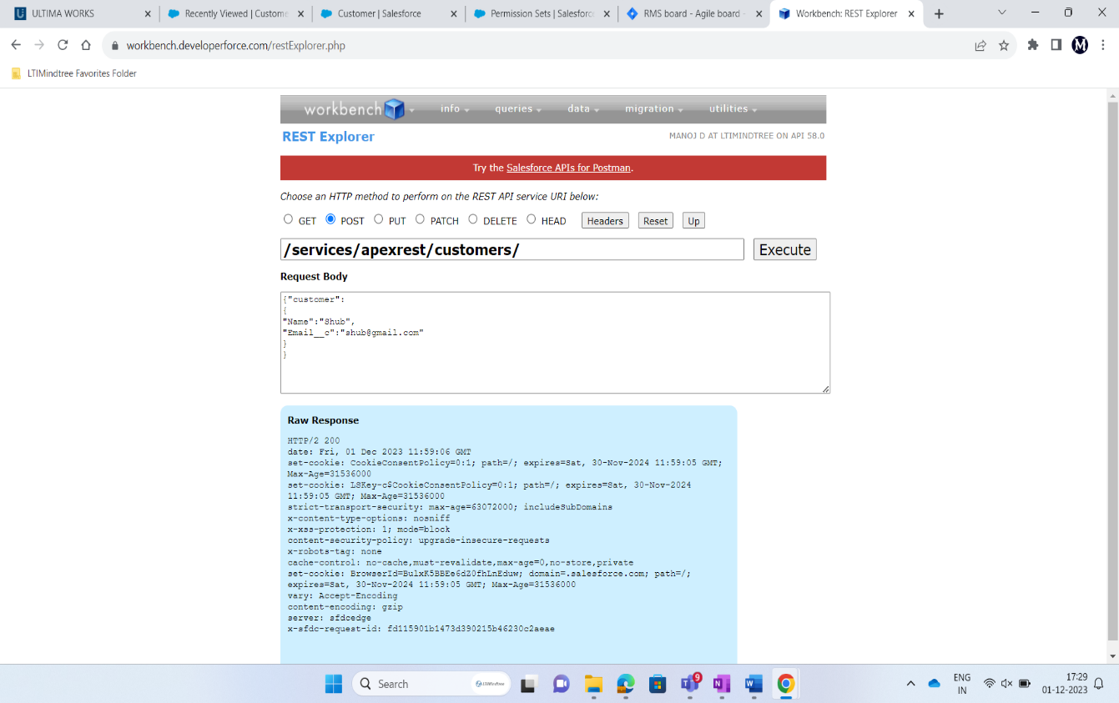

**LWC (Lightning Web Component)**

22. Create a LWC Component where you have to search **Customer** details either by Name or email and then populate searched result

* 1. Searched result must include following fields:
     1. CustomerId, Name, email, Status  
          
          
          
        Done